Lazy Dijkstra---using simple priority-queues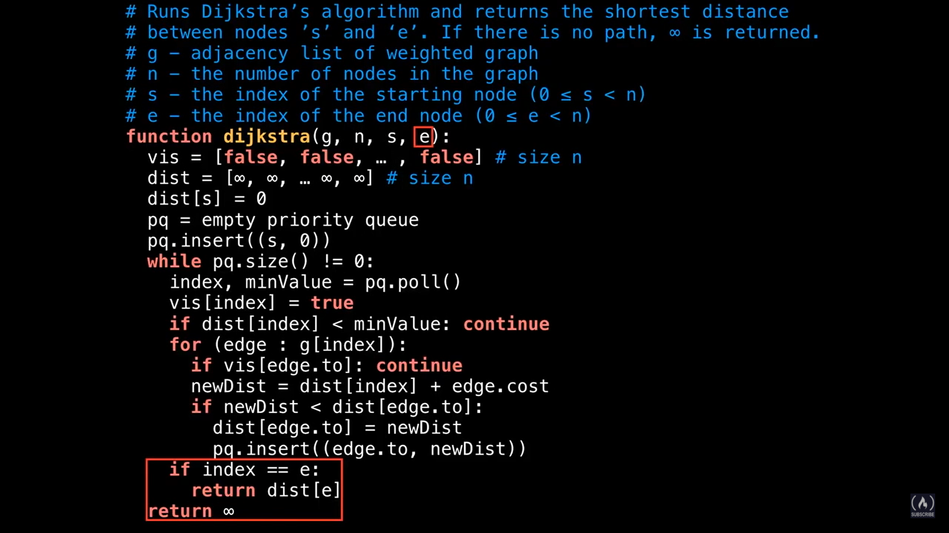

Eager Dijkstra—Using Indexed priority-queues(Queue with decrease key operation)

